Joe Lombardo
Governor

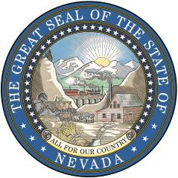
Jack Robb
Director

Matthew Tuma
Deputy Director

Wilfred J. Lewis, Jr.
Administrator

Carson City Office:
515 East Musser Street, Suite 102
Carson City, Nevada 89701
Phone: (775) 684-4141
Buildings & Grounds Section
Phone: (775) 684-1800
State of Nevada
Department of Administration
Public Works Division
Las Vegas Office:
2300 McLeod Street
Las Vegas, Nevada 89104
Phone: (702) 486-5115
Buildings & Grounds Section
Phone: (702) 486-4300

MEMORANDUM

WE’VE MOVED

This is to inform you that as of February 29, 2024, State Public Works Board, Professional Services and Administration office has moved to their new location 680 W. Nye Lane Carson City, NV 89703. Additionally State Public Works Building & Grounds Division has moved to their new location 406 E. 2nd Street Carson City, NV 89701.

Thank you

